Proxy

* Representation
* Simplified/**lightweight**

Proxy Design Pattern

* Represent a real subject class
* Hides reference

Why use

* To act as a virtual proxy
  + Some actual classes are resource intensive to instantiate
    - Eg: visual editors
* To act as a protection proxy
  + Credentials
* To act as a remote proxy
  + Google documents that exist on a google server somewhere else

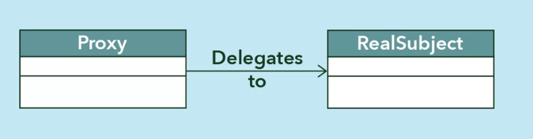

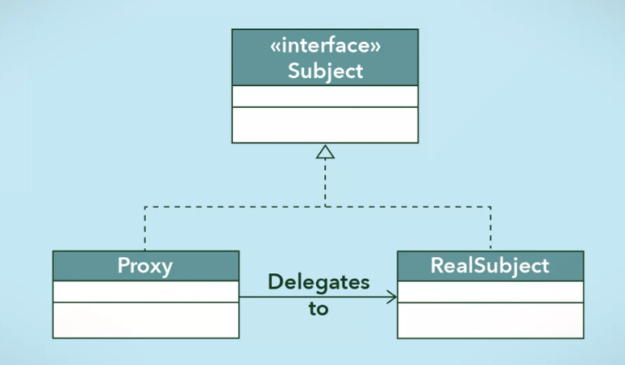

* Must offer same interface

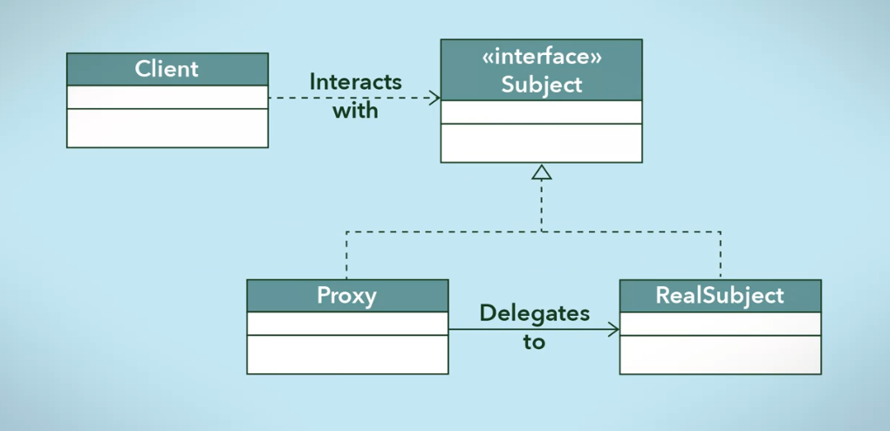

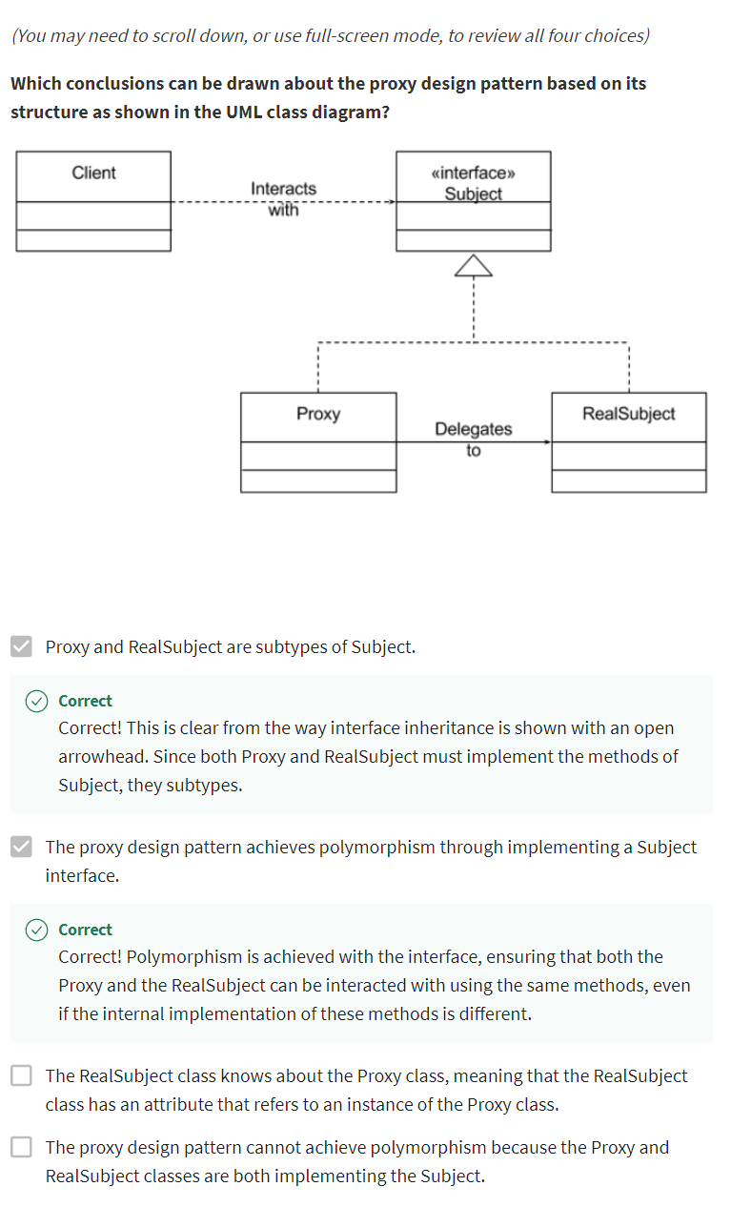

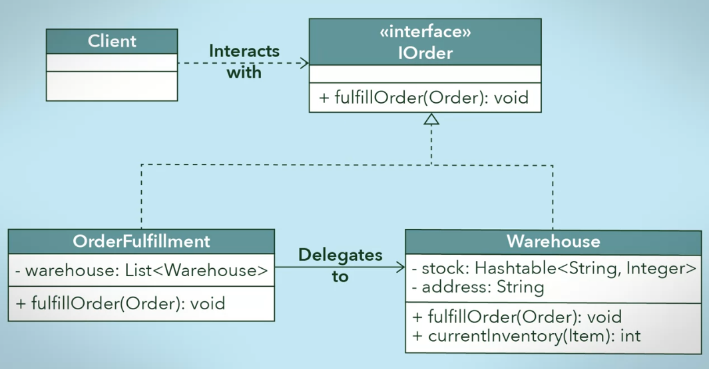

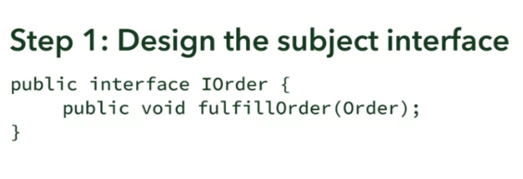

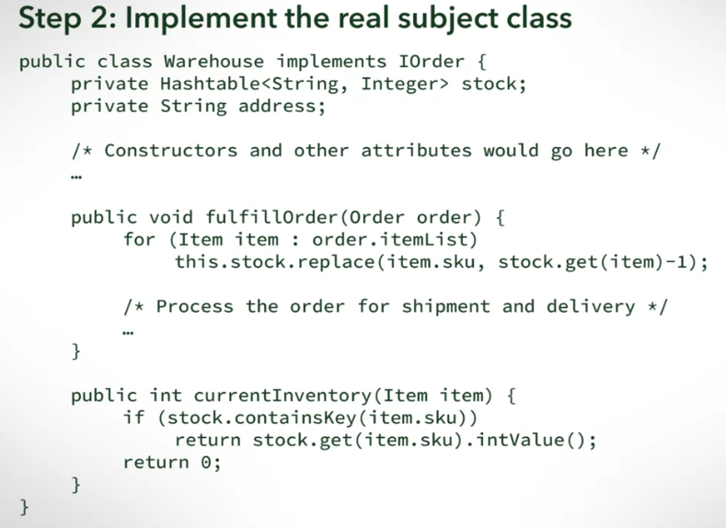

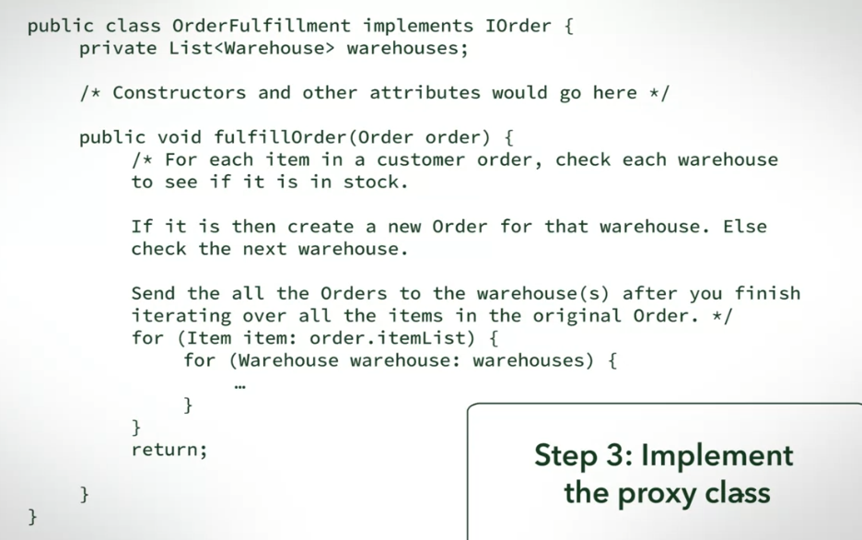

* Dito nagccheck ng order
* Parang FE, iccheck muna bago magrequest sa BE

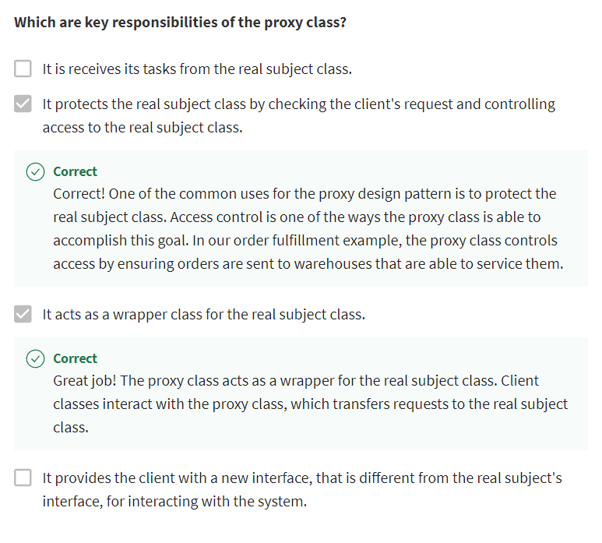

Summary

